Supported Decision-Making

A User’s Guide for
People with Disabilities and Their Supporters

Promoting Independence as an Alternative to Guardianship in Maine

Acknowledgements
Disability Rights Maine would like to sincerely thank the South Carolina Developmental Disabilities Council, Protection and Advocacy for People with Disabilities, Inc. (the Protection and Advocacy Agency in South Carolina), and the South Carolina Supported Decision-Making Project. This Guide is based in large part upon the Supported Decision-Making manual created through their collaboration.
DRM would also like to thank Supported Decision-Making New York (SDMNY) and Honorable Kristin Booth Glen for their invaluable training and inspiration.
DRM also extends warm thanks to our partners for their support of this handbook: the self-advocates of Maine’s Developmental Disabilities Partners for Positive Change, the Maine Developmental Disabilities Council, the Center for Inclusion and Disability Studies, Maine Parent Federation, and Speaking Up for Us.
Introduction

Purpose of this Manual
This Guide was created by Disability Rights Maine to provide information about Supported Decision-Making to individuals with disabilities and their families and supporters. The goal of this Guide is to illustrate how Supported Decision-Making can be used to help people with disabilities in making their own decisions, and in reducing more restrictive means of support such as guardianship. Supported Decision-Making can help preserve a person’s autonomy and independence, while still providing the person with support from family, friends, and community.
For questions or more information, please contact Disability Rights Maine at 1-800-452-1948, send an email to advocate@drme.org, or visit our websites at www.supportmydecision.org and www.drme.org.

Disclaimer
This material is presented for educational purposes only. It is not and does not take the place of legal advice in any specific situation, nor is it offered as such by the author. The information contained herein is based on the law at the time this Guide was produced. If you have questions about your legal rights, please consult an attorney.

Table of Contents
Chapter 1: Overview of Supported Decision-Making 4
What is Supported Decision-Making? 4
Benefits of Supported Decision-Making 7
Supported Decision-Making in Maine 8
Supported Decision-Making As an Alternative to Guardianship 9
Chapter 2: Other Alternatives to Guardianship 10
Power of Attorney 10
Release of Information 11
Trust 11
Representative Payee Program 12
Assistive Technology 12
Chapter 3: Self-Advocacy in Supported Decision-Making 15
Supported Decision-Making and Transition Planning 15
Supported Decision-Making for People Already Under Guardianship 16
Chapter 4: Identifying Which Types of Decisions Need Support and What Kind of Support Is Wanted 17
Chapter 5: Choosing Supporters 26
Talking to Potential Supporters 27
Chapter 6: Filling out a Supported Decision-Making Agreement 28
Additional Resources 31

A sample Supported Decision-Making Agreement appears at the end of this Guide.

Chapter 1: Overview of Supported Decision-Making

What is Supported Decision-Making?
Supported Decision-Making (sometimes referred to as SDM) is “a series of relationships, practices, arrangements, and agreements of more or less formality and intensity designed to assist an individual with a disability to make and communicate to others decisions about the individual’s life.”
Put more simply, Supported Decision-Making is a model to support people with disabilities in making and communicating their own decisions about their lives.
We all use Supported Decision-Making. For example, many people consult with family and friends before making big decisions, such as where to live. Sometimes we consult with experts to help us make complicated decisions, such as talking to our doctors about medical decisions. Talking to experts can help us understand complicated information, even though the final decision is up to us, not the doctor.
Supported Decision-Making emphasizes the importance of all people deciding what their lives should look like.
At the center of SDM is the Decision-Maker. The Decision-Maker chooses people whom she would like to help her make decisions. These people are called supporters, and they can be family, friends, service providers…anyone that the Decision-Maker chooses, as long as the supporters agree to serve in this role.
The Decision-Maker decides what kinds of decisions she would like help with. Examples include decisions about how to spend money, where to live, education, relationships, or healthcare.
The Decision-Maker also decides what kind of help she would like in making certain types of decisions. For example, the Decision-Maker may want help with gathering information. Or, she may want help with understanding information. Or, she may want help with communicating a decision to others. The possibilities are endless.
Supported Decision-Making can be as formal or as informal as the Decision-Maker would like it to be. The individual and her supporters may sign a Supported Decision-Making Agreement (SDMA). This is a written plan, developed by the Decision-Maker and her team, that gives information about who the supporters will be, what kind of decisions will be supported, and what kind of support is requested. An example of a Supported Decision-Making Agreement can be found at the end of this Guide. It can be filled out as written, or it can be changed to suit the needs of the individual.
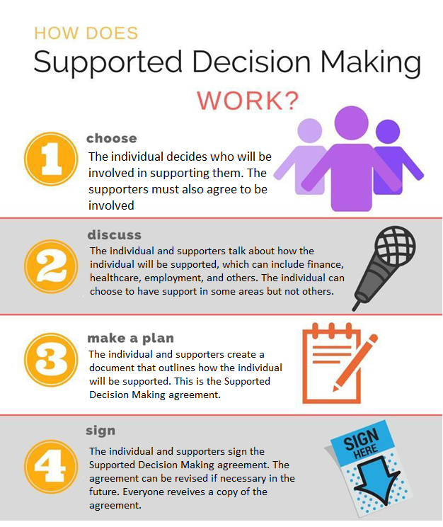

Benefits of Supported Decision-Making
Supported Decision-Making is based on the idea of self-determination. This means that an individual directs the plan for her own life. She decides what is most important to her, sets goals, and, with the help of those around her, works to achieve those goals so that she can live the most fulfilling life possible.
All people deserve a life of independence, gainful employment, and fulfilling relationships with friends and romantic partners. Supported Decision-Making is based on the idea that making decisions is a skill that can be learned. Supported Decision-Making helps people learn to manage and avoid risks. This is known as “dignity of risk,” and it means that taking reasonable risks is a necessary part of self-determination and self-esteem. Supported Decision-Making preserves dignity of risk.
Several studies have found that people who exercise more self-determination are more likely to live independently, have greater financial independence, be employed at higher paying jobs, and make greater advances in their employment. In addition, self-determination has been shown as a predictor of post-high school success in employment and independent living.

Supported Decision-Making in Maine
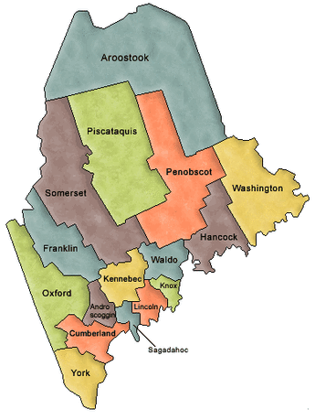
Supported Decision-Making has been gaining momentum in the United States and internationally. In the U.S., Supported Decision-Making has been endorsed and promoted by the American Bar Association, the National Guardianship Association, and a number of federal advisory bodies and agencies, including the Department of Education, the Department of Health and Human Services, and the National Council on Disability.
Likewise, in Maine, people have been utilizing the concept of Supported Decision-Making more and more. Disability Rights Maine was a founding partner of the Supported Decision-Making Coalition, which sought to bring SDM to Maine. Other Coalition members included individuals with disabilities, the Maine Department of Education, Legal Services for the Elderly, the Maine Long-Term Care Ombudsman Program, the Maine Department of Health and Human Services (DHHS), the Maine Developmental Disabilities Council, the Maine Parent Federation, the Maine Center for Community Inclusion and Disability Studies, and adult and children service providers. DHHS has been promoting Supported Decision-Making for transition-age youth in its Guide to Transition Services since 2016.
As of September 2019, Maine’s new Probate Code is in effect. It specifically requires that less-restrictive alternatives, including Supported Decision-Making, be attempted before a probate court will consider granting a guardianship. The adoption of this new Probate Code shows that Maine is recognizing the importance of self-determination, and that guardianship is to be used only as a last resort. If a guardian is appointed, Maine law requires that a guardianship be limited to only those areas in which the individual needs assistance. Overly restrictive measures can limit an individual’s development of important independent living skills.

Supported Decision-Making As an Alternative to Guardianship
It’s never too early to start thinking about Supported Decision-Making. Asking an individual where and with whom she’d like to live, or what kind of job she would like, can help set the foundation for Supported Decision-Making. Practice consent by having the person make decisions for herself. Note that because an individual makes a poor decision does not mean he or she is unfit to make decisions altogether. We all make bad decisions sometimes. All people should have opportunities to learn from failure. Sound decision-making is a skill that must be learned and practiced over time, like many other skills that are necessary for independence.
Explore least restrictive supports first. Instead of focusing on what a person is unable to do, pay attention to her strengths. A person with a disability should experience responsibility instead of being shielded from decision-making. Explore informal supports and seek assistance from disability agencies that may offer skill-building and technical assistance. Medicaid waiver services and case managers can help connect people with supported employment services, independent living skills training, and other resources.
When considering the barriers to independence, ask whether they can be lessened by measures like assistive technology, training, opportunities to socialize, role-playing, and other means. Consider the person’s communication methods, mental state, access to stimulating environments, adequacy of supports, and side effects from medication before deciding that an individual is unable to make decisions.

Chapter 2: Other Alternatives to Guardianship
In addition to Supported Decision-Making, there are many other options to consider that address needs and promote safety and are less restrictive than guardianship. Below are some examples. They can all be used to promote independence and can be part of a Supported Decision-Making plan.

Power of Attorney
A Power of Attorney is a document that allows one person (an “agent”) to make certain types of decisions on behalf of another person (the “principal”). The principal signs a document, called the Power of Attorney, to allow the agent to make certain types of decisions for the principal. A Power of Attorney does not take away decision-making authority from the principal; it merely shares the decision-making authority with the agent. The title “Power of Attorney” can be confusing, because neither the principal nor the agent needs to be an attorney. A Power of Attorney usually authorizes an agent to make medical decisions (called a Healthcare Power of Attorney) or financial decisions (called a Financial Power of Attorney).
A Power of Attorney can be customized depending on when and under what circumstances a principal would like assistance. For example, a principal might only want his agent to be able to make healthcare decisions if the principal is unable to do so himself. A Healthcare Power of Attorney might specify what kind of end-of-life decisions a principal would like taken if the principal is unable to make those kinds of decisions himself. In Maine, this is called an Advance Healthcare Directive. Some people also refer to this type of document as a Living Will.
A Power of Attorney is less restrictive than a guardianship because it involves a principal sharing decision-making authority with an agent, whereas a guardianship takes away decision-making authority from one person and transfers it to another. The principal can revoke the Power of Attorney at any time, meaning it can be canceled. Powers of Attorney generally do not require court approval to create or to cancel.

Release of Information
It is against the law for certain types of providers such as medical providers, banks, or schools, to share personal information about their clients with others. Signing a release allows a provider to share information with another person of an individual’s choosing. For example, a patient may sign a release to allow his doctor to speak to his parents about his health care information. Or, a person may sign a release with his school to share certain information with his parents. A release does not allow the other person to make decisions for the individual; it only allows information to be shared. A release can be changed or revoked by the person at any time by letting the provider know.

Trust
Trusts allow a third party to hold money and assets on behalf of someone else (called a “beneficiary”). There are many different ways to set up a trust, and some are tailored specifically for those with disabilities so as not to impact other benefits. These are called Special Needs Trusts. Because of the many different ways a trust may be arranged, it is best to speak with a financial manager or an attorney who can accurately assess a person’s needs.

Representative Payee Program
Offered through the Social Security Administration, this program allows a representative to manage a beneficiary’s Social Security or SSI payments. A representative may be responsible for using benefits to pay an individual’s expenses and keeping track of expenditures. Typically a family member or other trusted adult is chosen to act in this role. However, one may be appointed through the Administration.

Assistive Technology
Today, there are more kinds of technology than ever before that can help people be more independent. Some types of technology are very simple, such as devices that help people manage their medication by organizing medication and providing reminders. There is also financial technology that can be automated to help people pay recurring bills, or learn to budget and manage their own money. There is technology to help people communicate and technology to help people with everyday tasks such as cooking. Chances are, if a person needs assistance with a certain task, there is a type of technology that can help that person complete that task independently.

Examples of Options to Address Various Needs Related to Decision-Making:
Need | Task | Can this be accomplished by:
Money Management | - Learning to recognize and prevent exploitation  - Managing accounts, assets, and benefits | - Money-managing app on phone  - Seeking financial counseling  - Representative Payee Program  - Conservatorship or trust
Healthcare | - Taking medications as needed  - Maintaining hygiene and diet  - Avoiding high-risk behaviors  - Making decisions about medical treatment | - Using apps to help remember to take medication and perform hygiene tasks  - Getting advice from professionals  - Visiting a healthcare professional to discuss information regarding prevention and safety  - Allowing a home health aide to assist in daily living tasks  - Having individual sign HIPAA release  - Obtaining Healthcare Power of Attorney or Living Will
Employment | - Looking for, gaining, and retaining employment | - Enrolling in job coaching services, such as supported employment programs  - Using Vocational Rehabilitation, Medicaid waiver services, or other employment providers to become job-ready
Relationships | - Behaving appropriately with friends, family, and co-workers  - Making decisions about sexual relationships | - Role-playing and practicing appropriate behavior  - Visiting a health center to learn more about contraception  - Speaking with loved ones about healthy relationships
Community Living | - Living independently  - Maintaining habitable conditions  - Accessing community resources | - Incorporating adaptive and assistive technology  - Setting reminders to complete home maintenance tasks  - Making a list of community resources, such as transportation
Personal Decision-Making | - Understanding legal documents (contracts, leases, powers of attorney)  - Communicating wishes  - Understanding legal consequences of behavior | - Allowing supporters to help explain contracts and other legal documents  - Having the individual demonstrate understanding of consequences, such as through role-playing  - Seeking advice from professionals
Personal Safety | - Avoiding common dangers  - Recognizing and avoiding abuse  - Knowing what to do in an emergency | - Role-playing scenarios, such as what to do in case of fire  - Discussing signs of healthy and unhealthy relationships and abusive behaviors  - Writing down emergency numbers

Chapter 3: Self-Advocacy in Supported Decision-Making
Sometimes, the most valuable support is helping a person with a disability advocate for herself. Advocating for yourself means letting others know what you want and need. All people have civil rights. All people have the right to make decisions about their own lives, including where they work, live, and with whom they spend time. All people have the right to vote and get married if they choose. All people have the right to make decisions about medical treatment and medication.
Most of us need help making decisions, so we turn to those we trust to guide us. For example, you might want your parents to be able to come into the exam room with you at the doctor’s office so they can ask any questions you may forget to ask. Or, you may want a family friend to help you with finances because paying the bills and keeping track of how your money is spent can be complicated. You don’t have to have a written agreement for people to assist you in decision-making, but it may be helpful so everyone is clear on how you want to receive this support.
A Supported Decision-Making Agreement lets others know who will help you, with what areas you need support, and what kind of support you would like. Remember, just because you may need help in some areas does not mean you are unable to make decisions for yourself! Like any skill, decision-making takes practice.

Supported Decision-Making and Transition Planning
Supported Decision-Making is intended for children, adolescents, and adults. The earlier a person and her supporters start learning about and using Supported Decision-Making, the better! It is never too early to begin learning the skill of decision-making.
Supported Decision-Making can and should be part of the process of transition planning for young people entering adulthood. In Maine, turning age 18, also called the “age of majority,” means that all of the rights and responsibilities formerly held by the young person’s parents or guardians are transferred to the young person. The young adult can now legally consent to medical care, make financial decisions, get married, and enter into legal contracts such as leases. When they turn 18, young adults who receive special education services are now the decision-makers with regard to IEPs and transitioning to adult services.
Turning 18 does not mean that a young adult can’t access supports. To the contrary, Supported Decision-Making encourages young people to identify areas where they need support and to identify people to help them make decisions. A student can use Supported Decision-Making as part of an IEP, notify her team who her supporters are, request that the school share information with her supporters, and inform her supporters of upcoming meetings.

Supported Decision-Making for People Already Under Guardianship
Supported Decision-Making may be a tool that can prevent a person from coming under guardianship, but it can also be a useful tool for people already under guardianship. Supported Decision-Making can help a person under guardianship be more involved in decision-making. The end result might be ending the guardianship, limiting the guardianship, or otherwise giving people subject to guardianship more control and self-determination over their own lives.

Chapter 4: Identifying Which Types of Decisions Need Support and What Kind of Support Is Wanted
There are many areas of life in which a person might need help with making decisions. Some examples might be decisions involving finances, healthcare, education, employment, housing, social life and relationships, or legal matters. A person might want help with other kinds of decisions not listed here. The Decision-Maker needs to think about which kinds of decisions he can make alone, and which might require some support.
Thinking about what kind of decisions you might need support with leads to thinking about what kind of support you would like. There are many types of support available to help a person make decisions. Some kinds of support are:
- Support in gathering information needed to make a decision
  - For example, you might want help with gathering information about available apartments in order to make a decision about where to live.
- Support in understanding information
  - For example, you might want help understanding the language in a lease in order to decide whether to sign it. Or, you might want help understanding what a doctor is recommending in order to decide on medical treatment.
- Support in understanding the consequences of different decisions
  - For example, it might be helpful to make a list, or discuss pros and cons to making a particular decision.
- Role-playing activities to help understand choices
- Bringing a supporter to personal appointments, such as doctor appointments, in order to take notes and help you remember information and discuss your options
- Advocating for extra time to think about choices and make decisions
- Taking classes to learn about healthy choices, such as classes about healthy relationships, or learning about finances
- Identifying technology that might increase independence
  - For example, there are payment apps that can make automatic payments to regular bills, budgeting software, or calendar reminders.
- Helping you communicate your decision to others
- Helping to make sure your decisions are carried out
You might want different types of support with different types of decisions. For example, you might want a higher level of support in making medical decisions than you do in making housing decisions. Supported Decision-Making Agreements are meant to be individualized so that the Decision-Maker is getting exactly the type of support he or she would like to have.
When Do I Want Support and What Kind of Support Do I Want?
The following chart can help you decide what kind of decisions you would like support with, and what kind of support you would like.
Check the boxes to say if you need support in each area, though not every category may be applicable to you. When you check the “I need some support” box, you should think about who you might want to support you, and write what kind of support you need under the corresponding box. You can use the information in this form to help you fill out a Supported Decision-Making Agreement.
 | I can do this alone | I need some support | What kind of support do I need?
Money Management
Paying the rent and bills on time (for example, cell phone, electricity, internet)
Keeping a budget so I know how much money I can spend
Making big decisions about money (for example, opening a bank account, signing a lease)
Making sure no one is taking my money or using it for themselves
Healthcare
Choosing when to go to the doctor or the dentist
Making medical choices in everyday situations (for example, check-up, medicine from the drug store)
Making medical choices in serious situations (for example, surgery, big injury)
Making medical choices in an emergency
Understanding how healthcare costs are covered (for example, Medicaid, private insurance, etc.)
Making choices about birth control or pregnancy
Remembering to take medicine
Making decisions about maintaining a healthy lifestyle
Education
What classes I will take
What accommodations I need at school
Deciding what college to attend or what to do after high school
Telling people what I want and don’t want
Telling people how I make choices
Making sure people understand what I am saying
Employment
Choosing if I want to work
Understanding my work choices
Choosing classes or training I need to get a job I want, and taking these classes
Applying for a job
Going to my job every work day
Knowing what accommodations I need at work and how to request them
Understanding the employee handbook or work policies
Relationships
Making choices about sex
Choosing if I want to date, and who I want to date
Making choices about marriage
Community Living
Choosing where I live
Choosing who I live with
Choosing what to do and who to see in my free time
Keeping my room or home clean
Finding support services and hiring and firing support staff
Traveling to places I go often (for example, getting to work, stores, friends’ homes)
Traveling to places I do not go often (for example, doctor’s appointments, special events)
Choosing what I wear
Getting dressed
Taking care of my personal hygiene (for example, showering, bathing, brushing teeth)
Choosing what to eat, and when to eat
Legal Matters
Talking to an attorney if I need one
Help understanding my rights
Signing contracts and formal agreements

Personal Safety
How to plan for an emergency
Making safe choices around the house (for example, turning off the stove, having fire alarms)
Making safe choices in the community
Understanding and getting help if I am being treated badly (abused, neglected, or exploited)
Other
Choosing who to vote for and voting
Making choices about alcohol and drugs

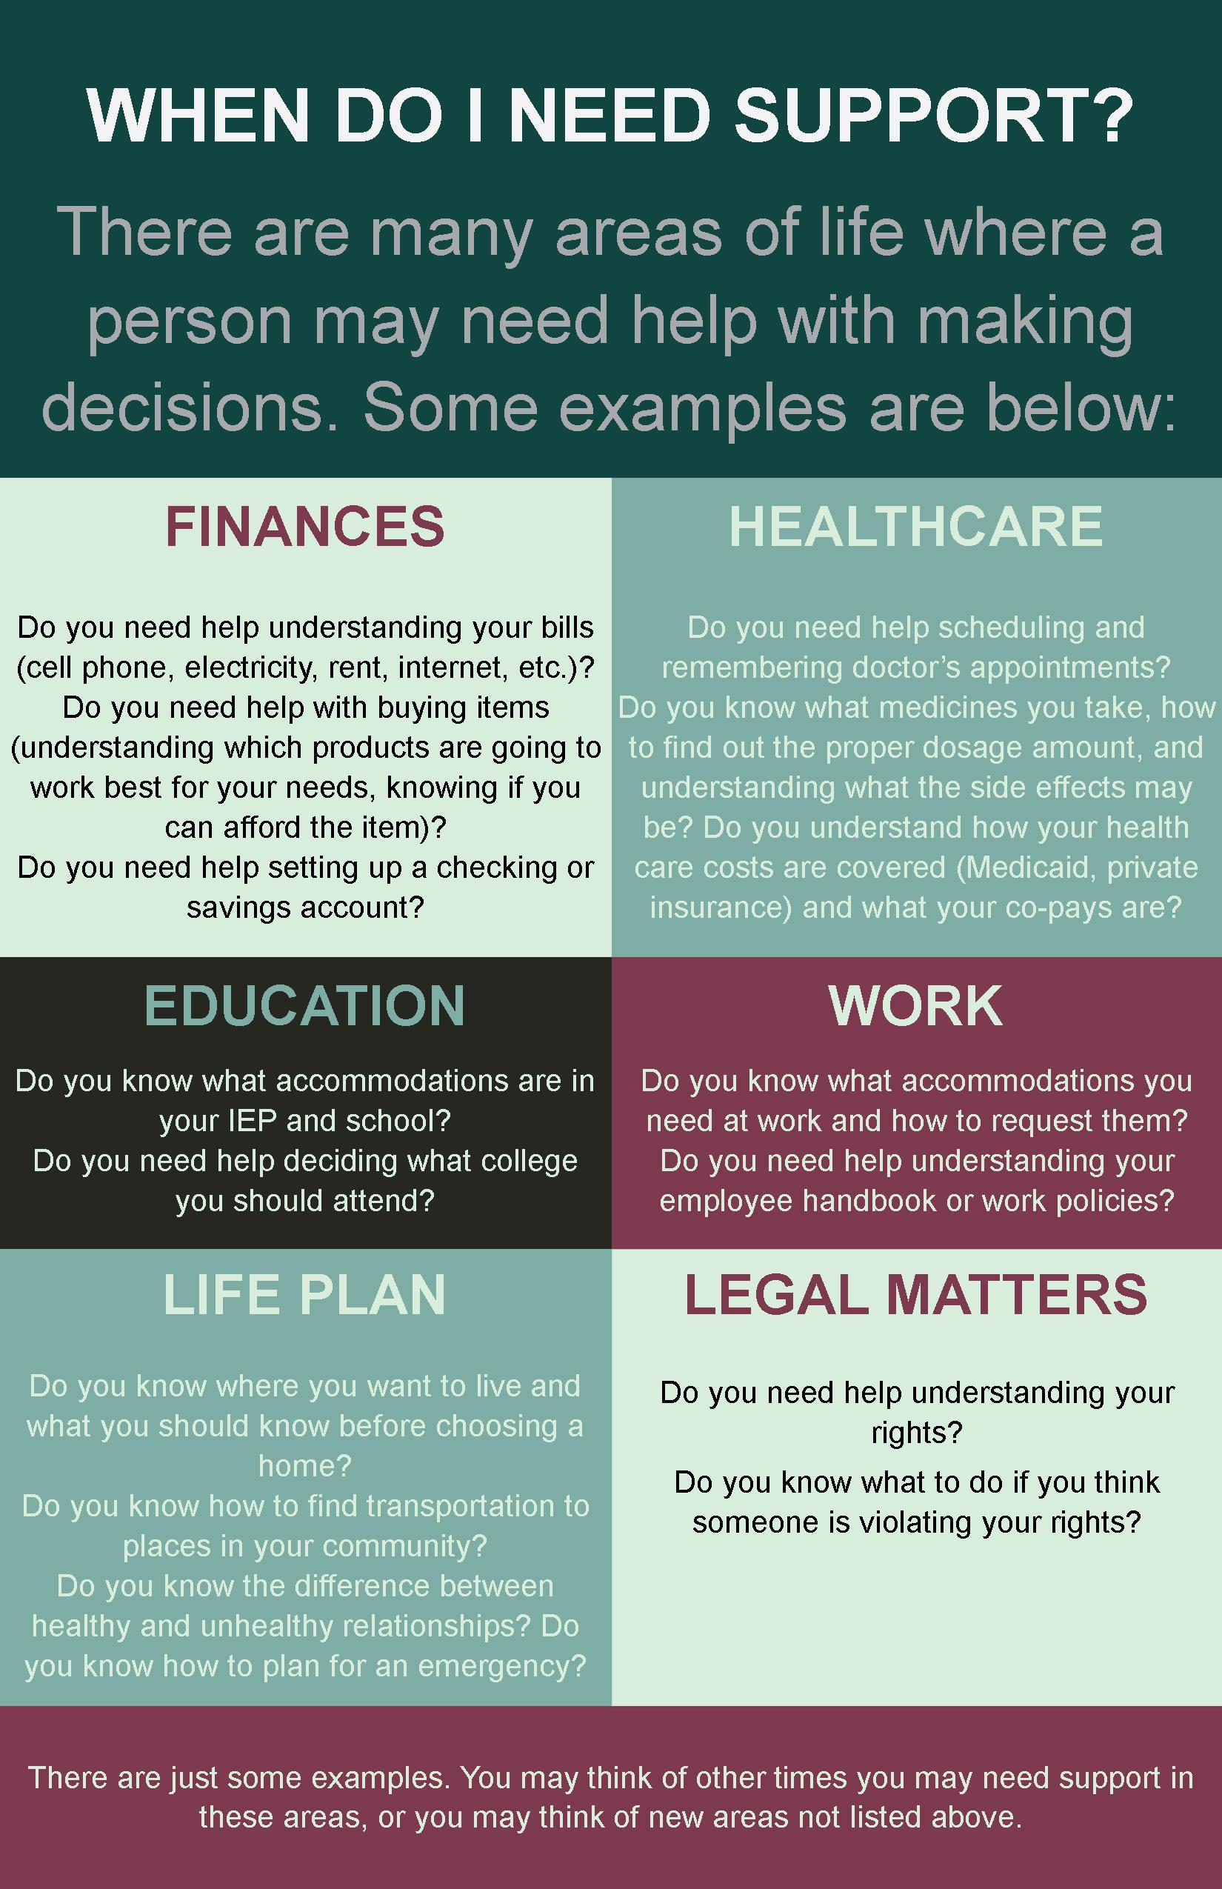

Chapter 5: Choosing Supporters
Choosing supporters might be the most important part of Supported Decision-Making. For some people, this might be the easiest thing to choose, and for some people, this might be the most difficult. The most important thing to remember is that it is the Decision-Maker who chooses who to use as supporters. Supporters should be people that the Decision-Maker knows and trusts to provide the type of support he wants for the types of decisions he wants support with. In other words, good supporters will follow the plan set forth in the Supported Decision-Making Agreement and will never substitute their own choices for those of the Decision-Maker.
Supporters can be family members, friends, neighbors, service coordinators, advocates, church members, professionals in the community, or anyone else the Decision-Maker wants involved. Decision-Makers can assign certain supporters to certain types of decisions and not others. For example, a person may want his friend to provide support for decisions about housing, but may want his sister to provide support for decisions about finances. A person can choose as many supporters as he wants. Decision-Makers can fire their supporters at any time, and supporters have the option of quitting as well. No one should force the Decision-Maker into choosing him or her as a supporter. Supporters should not help make decisions in areas that the Decision-Maker did not agree to, and they should never make decisions for the Decision-Maker. The Decision-Maker is at the center of the Supported Decision-Making Agreement at all times!

Talking to Potential Supporters
Once a person chooses whom he trusts to help him make decisions, he will need to find out if the potential supporter is able and willing to help. The Decision-Maker might:
- Share what areas in which he would like support
- Share how he would like to get support
- Share a sample Supported Decision-Making Agreement
It is important that the potential supporter understand what is involved, and be able and willing to fulfill the role of supporter.
Sometimes it can be difficult for people to identify supporters. Not everyone has a solid network of support in place. If this is the case, it will be important to consider how to create relationships and build up a network of people that could provide support. Think about ways in which relationships are made. Is there family who might make good supporters? What about attending community events, seeking out organizations that match people up with mentors, looking for supports at places of worship or school, or other places where relationships can be made? It can take time to build healthy and trusting relationships with potential supporters, but it can also be very worthwhile. Everyone benefits from having community support, whether or not it is for the purposes of Supported Decision-Making.

Chapter 6: Filling out a Supported Decision-Making Agreement
Once a Decision-Maker has thought about what kind of decisions she would like support with, what kind of support she would like, and who her supporters will be, it’s time to complete the Supported Decision-Making Agreement. You can find a sample Supported Decision-Making Agreement at the end of this Guide.
The Decision-Maker should meet with her supporters, either one at a time, or all at once, depending on what works best. They should go over the Agreement page-by-page and make sure that everyone understands and agrees upon what is in the Agreement. It is as important for supporters to understand what kind of help the Decision-Maker does not want as it is for them to understand what kind of help is wanted.
Once the Agreement is completed, everyone should sign the Agreement. Signing the Agreement means that everyone understands and promises to do their best to honor what it says. The Decision-Maker should not sign the Agreement until she is in front of a notary. A notary is a type of witness when official documents are signed. The notary makes sure that the person signing the Agreement is who she says she is, and also makes sure that the person signing is not being pressured or forced to sign something that she does not want to sign. Banks, post offices, and law offices usually have people who are able to notarize documents. Sometimes they charge a small fee, but many times you can find one to do it for free.
Remember that a Supported Decision-Making Agreement is a “living document.” This means that it can be changed as needed. A Decision-Maker may want to change a supporter, or have a different type of help in making a certain kind of decision. A supporter may decide to drop out. Or, a new supporter may be identified. The Supported Decision-Making Agreement is meant to be easy to change. The most important thing is that the Decision-Maker is getting the kind of help she wants in the areas she wants the help, from the people that she wants to help her.
Once the Supported Decision-Making Agreement is signed, the team is ready to use Supported Decision-Making! The Decision-Maker and the supporters should each have a copy of the Agreement. It’s also a good idea to share the SDMA with doctors, banks, or others who will be expected to acknowledge and honor the Agreement. Some people like to celebrate this milestone!
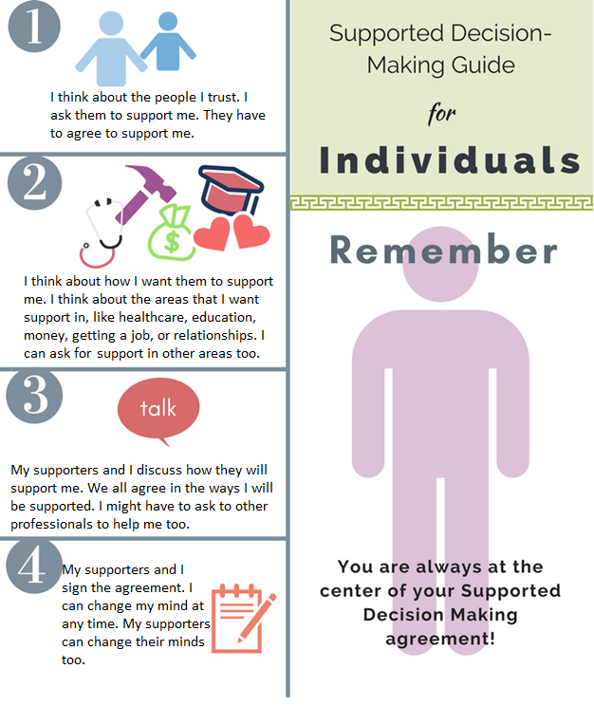

Additional Resources
National Resource Center for Supported Decision-Making
National and local resources and information about Supported Decision-Making
http://supporteddecisionmaking.org
202-448-1448

American Civil Liberties Union Disability Rights Program
www.aclu.org/supported-decision-making-resource-library

Center for Public Representation Supported Decision-Making Pilot Project
www.supporteddecisions.org

Autistic Self-Advocacy Network (ASAN)
The Right To Make Choices, a series of very detailed, Easy Read documents ASAN put together to provide self-advocates with an overview of SDM and some of the many different options available.
https://autisticadvocacy.org/2016/02/the-right-to-make-choices-new-resource-on-supported-decision-making/

PRACTICAL Tool for Lawyers: Steps in Supported Decision-Making
Helps lawyers identify and implement decision-making options for persons with disabilities that are less restrictive than guardianship.
www.ambar.org/practicaltool

I’m Determined Project
Focuses on providing direct instruction, models, and opportunities to practice skills associated with self-determined behavior. Look under the “resources” tab for activities and worksheets.
www.imdetermined.org

Supported Decision-Making Agreement
This is the Supported Decision-Making Agreement of:
Name: _________________________ DOB: ______________
Address:_____________________________________________
Phone: _____________________________________________

This Agreement is used for the appointment of supporters to help me make my own decisions. This Agreement is effective because I am at least 18 years of age and am able to understand the nature and effect of this Agreement.
I want to have people I trust help me make decisions. The people who will help me are called supporters.
My supporters are not allowed to make choices for me. I will make my own choices, with support. I am called the Decision-Maker.
This Agreement can be changed at any time. I can change it by crossing out words and writing my initials next to the changes. Or, I can change it by writing new information on another piece of paper, signing that paper, and attaching it to this Agreement.

Designation of Supporters

I, ____________________ (Decision-Maker), choose the following people as my supporters:
Supporter #1:
Name: __________________________ DOB: ______________
Address: _____________________________________________
Phone: __________ Relationship to Decision-Maker: _________
Supporter #2:
Name: __________________________ DOB: ______________
Address: _____________________________________________
Phone: __________ Relationship to Decision-Maker: _________
Supporter #3:
Name: __________________________ DOB: ______________
Address: _____________________________________________
Phone: __________ Relationship to Decision-Maker: _________
Supporter #4:
Name: __________________________ DOB: ______________
Address: _____________________________________________
Phone: __________ Relationship to Decision-Maker: _________
Add more pages as needed.
Areas and Types of Support
(1.) ____________________________________ (names of 1 or more supporters) will provide me with support in the area of ___________________________________________.
S/he will provide me the following kinds of support (check only the kinds of support the Decision-Maker wants):
□ Gathering information;
□ Helping me to understand information;
□ Identifying possibilities and alternatives;
□ Helping me weigh my options;
□ Helping me to understand consequences;
□ Communicating my decisions to others;
□ Helping me to carry out my decisions;
□ Other: ________________________________________.
(2.) ____________________________________ (names of 1 or more supporters) will provide me with support in the area of ___________________________________________.
S/he will provide me the following kinds of support (check only the kinds of support the Decision-Maker wants):
□ Gathering information;
□ Helping me to understand information;
□ Identifying possibilities and alternatives;
□ Helping me weigh my options;
□ Helping me to understand consequences;
□ Communicating my decisions to others;
□ Helping me to carry out my decisions;
□ Other: ________________________________________.
(3.) ____________________________________ (names of 1 or more supporters) will provide me with support in the area of ___________________________________________.
S/he will provide me the following kinds of support (check only the kinds of support the Decision-Maker wants):
□ Gathering information;
□ Helping me to understand information;
□ Identifying possibilities and alternatives;
□ Helping me weigh my options;
□ Helping me to understand consequences;
□ Communicating my decisions to others;
□ Helping me to carry out my decisions;
□ Other: ________________________________________.
Add more pages as needed.
Declining Support
I DO NOT want support in the area(s) of ____________________
_____________________________________________. I will make decisions in this/these areas without support.
I will make decisions in any other areas not listed in this Agreement without support.

Releases of Information
In order to give me the kind of support I am requesting, some of my supporters may need access to information about me that is confidential, such as medical information or school records. I will be signing the following types of releases to allow certain supporters to access this information for the purposes of this Supported Decision-Making Agreement. My supporters may access this information only for the purposes of supporting me in making decisions, and may not share this information with anyone else. I understand that a signed release does not allow another person to make decisions for me, and that I may cancel the Release of Information at any time by notifying the provider.
Types of releases that I may sign include releases for education records (a “FERPA” release), medical information (a “HIPAA” release), or a release for financial information (such as a release for bank records).
A Release of Information is a separate document that must be signed by the Decision-Maker and filed with the proper organization to be effective.
_______________________ ___________________________
Type of Release Supporter(s)

_______________________ ___________________________
Type of Release Supporter(s)

_______________________ ___________________________
Type of Release Supporter(s)

_______________________ ___________________________
Type of Release Supporter(s)

Other Instruments
I already have a: (check all that apply)
□ Financial Power of Attorney
□ Medical/Healthcare Power of Attorney
□ Advance Healthcare Directive
□ Social Security Representative Payee
Acceptance by Third Parties
I want third parties to rely on this Supported Decision-Making Agreement. I accept the actions of my supporters who act in accordance with this Agreement.
Effect and Revocation
This Agreement takes effect as soon as it is notarized and signed by the Decision-Maker and Supporters. This Agreement can be revoked at any time by the Decision-Maker by written or verbal notice to the Supporters. If a Supporter can no longer assist the Decision-Maker in the duties outlined above, s/he will provide the Decision-Maker with at least seven (7) days written notice.
Attestation and Signature of Supporters
I, __________________________ (name of supporter and relationship to Decision-Maker), have read and understand this Agreement. I agree to provide support in accordance with this Agreement and not act as a substitute Decision-Maker. In that role, I agree to avoid conflicts of interest and not to exert undue influence.
___________________________ _______________
Signature of Supporter Date

I, __________________________ (name of supporter and relationship to Decision-Maker), have read and understand this Agreement. I agree to provide support in accordance with this Agreement and not act as a substitute Decision-Maker. In that role, I agree to avoid conflicts of interest and not to exert undue influence.
___________________________ _______________
Signature of Supporter Date

I, __________________________ (name of supporter and relationship to Decision-Maker), have read and understand this Agreement. I agree to provide support in accordance with this Agreement and not act as a substitute Decision-Maker. In that role, I agree to avoid conflicts of interest and not to exert undue influence.
___________________________ _______________
Signature of Supporter Date
Add more pages as needed.
Designation and Oath of Decision-Maker
I hereby designate the above-signed individuals to be Supporters on my Supported Decision-Making Team. It is my understanding that my Supporters are resources to me and that I make all final decisions concerning my life. I also understand that I can remove a Supporter from my team, or change his or her access to my confidential information at any time.
_____________________________
Printed Name of Decision-Maker

_____________________________ _____________
Signature of Decision-Maker Date
Notarization
STATE OF MAINE
______________, ss.
Personally appeared the above-named individual and acknowledged the foregoing instrument to be his/her free act and deed.
Before me,
_________________________ ________________
Attorney at Law/Notary Public Date
Notes
________________________________________________________________________________________________________________________________________________________________________________________________________________________________________________________________________________________________________________________________________________________________________________________________________________________________________________________________________________________________________________________________________________________________________________________________________________________________________________________________________________________________________________________________________________________________________________________________________________________________________________________________________________________________________________________________________________________________________________________________________________

ENDNOTES Robert D. Dinerstein, Implementing Legal Capacity Under Article 12 of the UN Convention on the Rights of Persons with Disabilities: The Difficult Road from Guardianship to Supported Decision-Making, 19 Hum. Rts Brief 8, 10 (2012).
Wehymeyer, M.L., & Palmer, S.B. (2003). Adult outcomes for students with cognitive disabilities three-years after high school: The impact of self-determination. Education & Training Developmental Disabilities, 38(2), 131-44.
Test, D. W., Mazzotti, V. L., Mustian, A. L., Fowler, C. H., Kortering, L., & Kohler, P. (2009). Evidence-based secondary transition predictors for improving postschool outcomes for students with disabilities. Career Development for Exceptional Individuals, 32(3), 160-81.
Brief of Quality Trust of Individuals with Disabilities et al. as Amici Curiae Supporting Respondents in In Re: Guardianship of the Person and Estate of Ryan Keith Tonner, an Incapacitated Person. Case No. 14-0940 (TX, 2015).

